Grade: V Addition

Addition of numbers is discussed in the following steps how to add large numbers:
Step I:
We arrange the given numbers in columns, ones under ones, tens under tens, hundred under hundreds and so on.
Step II:
We add the digits in each column taking the carry over, if any, to the next column the left, and adding it along with the digit in that column. We continue this process till we add the digits in all the columns.
1. Add 3507469 and 6641007.
Therefore, the sum of given numbers= 10148476.
2. Add 4167499; 38014 and 3604587.
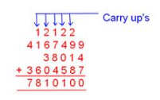
Therefore, the sum of given numbers= 7810100.

Subtraction
Subtraction of numbers is discussed in the following two steps to subtract one large number from another large number:
Step I:
We arrange the given numbers in columns, ones under ones, tens under tens, hundred under hundreds and so on.
Step II:
Beginning with the ones, we go on subtracting column wise, borrowing if necessary, from the next column to the left.
1. Subtract 2478652 from 8364579.
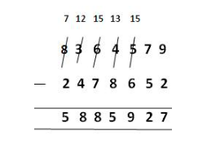
2. Subtract 1076799 from 1205620.
